CS 255 System Design Document Template

This template lays out all the different sections that you need to complete for Project Two. Each section has guidance to prompt your thinking. You will need to continually reference the interview transcript as you work to make sure that you are addressing your client’s needs. There is no required length for the final document. Instead the goal is to complete each section based on what your client’s needs are. Remove this note when you are finished, and replace all bracketed text with the relevant information.

UML Diagrams

UML Use Case Diagram
The UML use case diagram below summarizes how the major user groups (customers/students, instructors, secretaries, management, and IT administrators) interact with the DriverPass system to register, purchase packages, schedule lessons, take practice exams, and track progress. It also captures administrative capabilities such as managing users/roles, reporting, auditing changes, and receiving DMV updates.

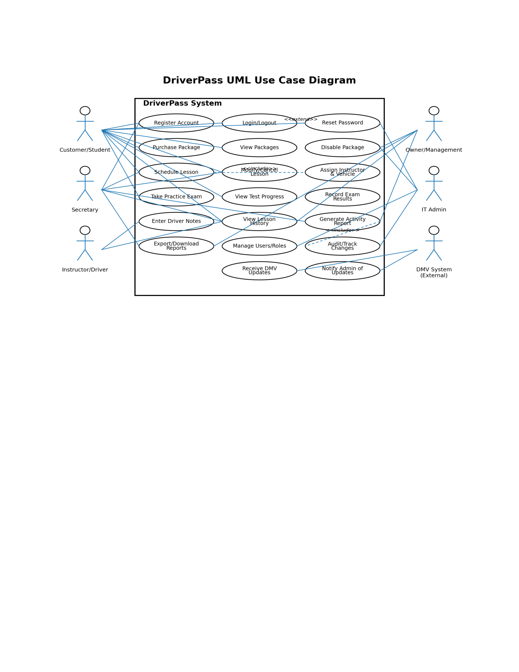

UML Activity Diagrams
Two activity diagrams are included below. The first models the end-to-end workflow for scheduling a lesson (including validation and conflict prevention). The second models the workflow for taking a practice exam and recording results for progress tracking.

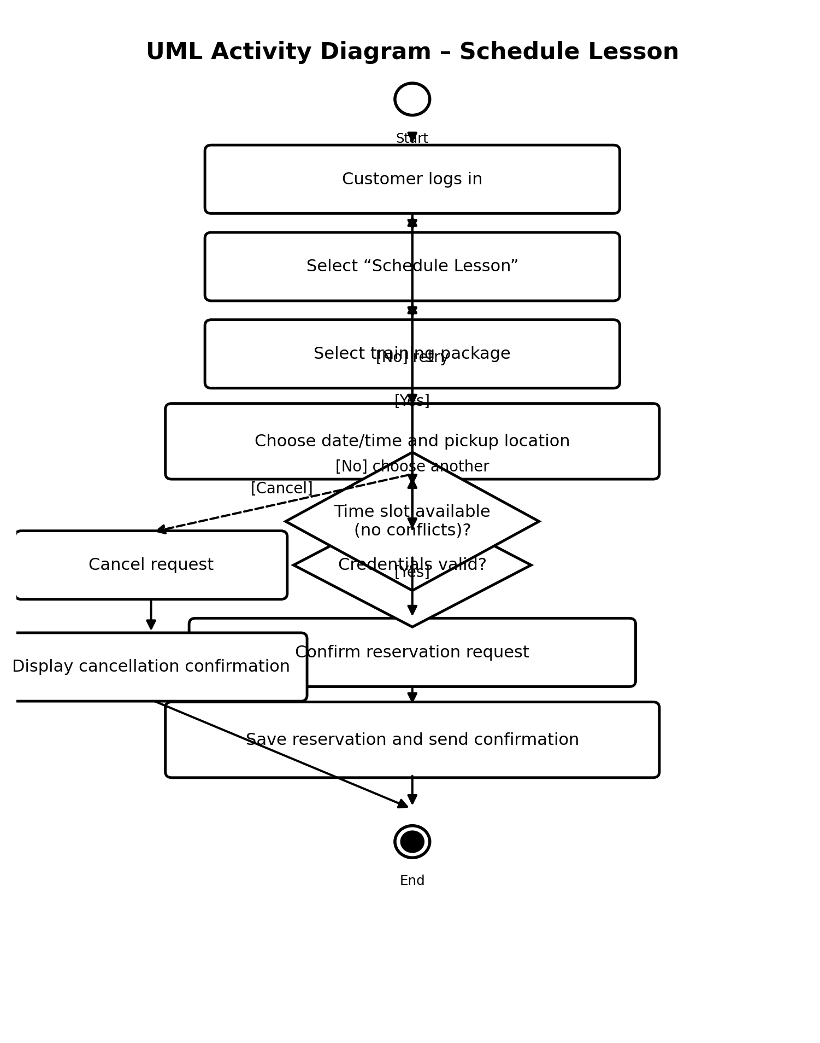

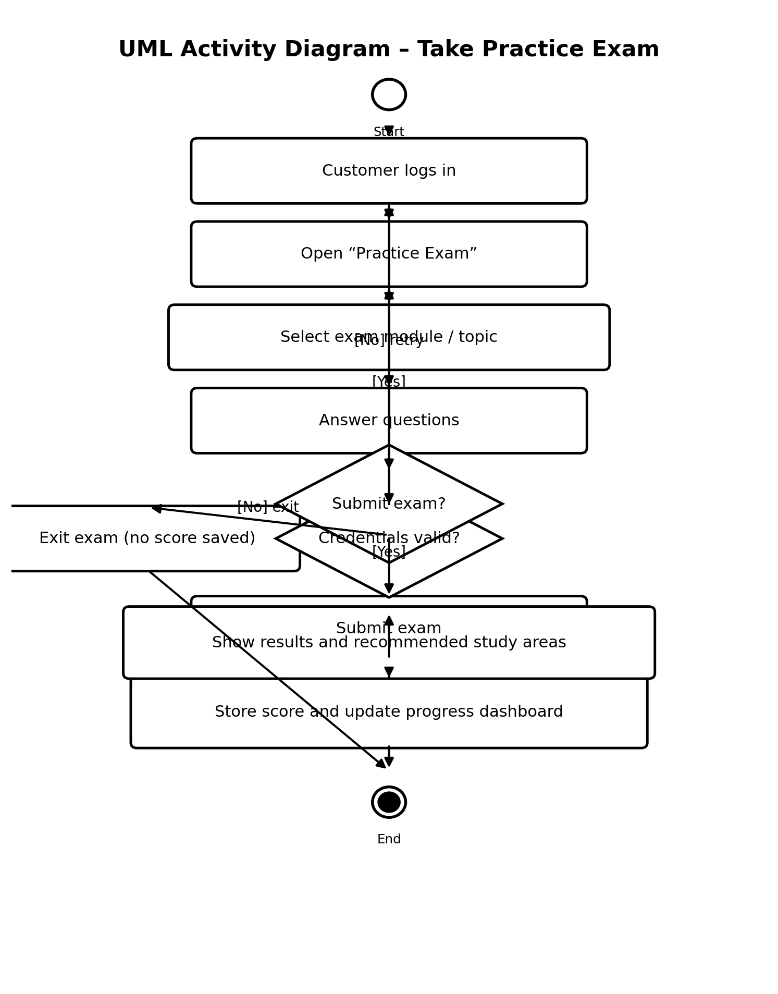

UML Sequence Diagram
The sequence diagram below shows the time-ordered interactions for the “Schedule Lesson” use case. It highlights how the customer, the web application, the reservation database, and a notification service collaborate to complete a reservation and deliver confirmation.

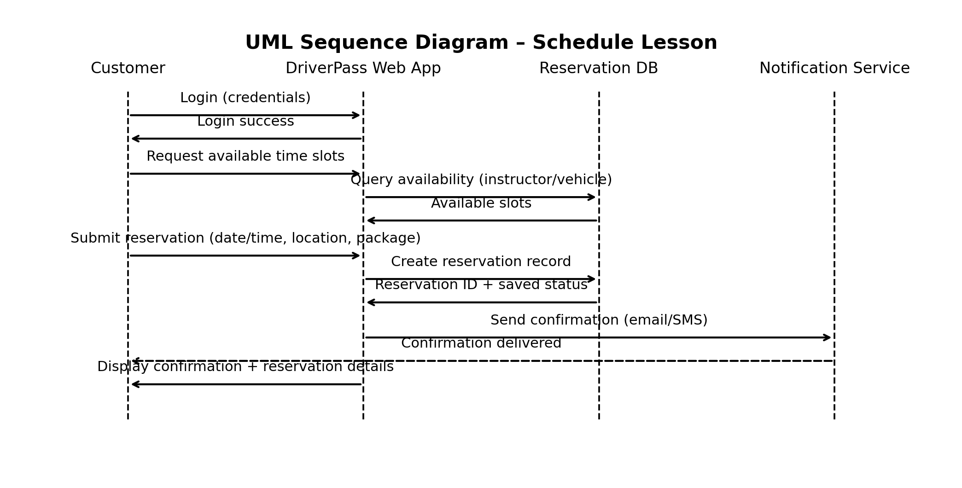

UML Class Diagram
The class diagram below captures the core objects and data needed to support DriverPass’s requirements. It includes users and roles, packages, reservations, vehicles, practice exams, exam attempts, notes, reports, and DMV updates/notifications.

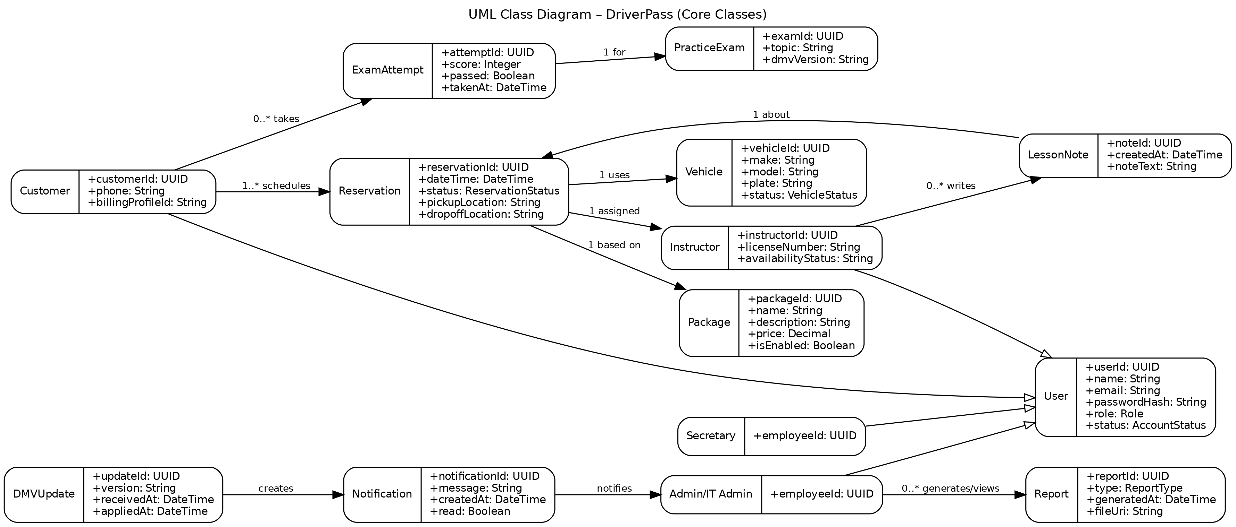

Technical Requirements
Hardware and Hosting
- Cloud hosting with autoscaling (AWS/Azure/GCP) and a managed load balancer.
- Minimum production baseline: 2 application servers (>= 2 vCPU / 8 GB RAM each) with automatic scaling to meet demand.
- Managed relational database (PostgreSQL/MySQL) with daily backups (RPO <= 24 hours, RTO <= 4 hours).
- Object storage for downloadable reports and uploaded files.
Software and Tools
- Web application accessible from modern browsers: Chrome, Edge (including IE mode if required), Firefox, and Safari (current and previous major versions).
- Responsive UI for desktop and mobile devices.
- CASE tool: Lucidchart for UML maintenance and updates.
Performance and Availability
- Page loads and key actions (login, scheduling search, exam submission) should complete within 5 seconds under typical 5G conditions (target >= 50 Mbps download / >= 10 Mbps upload).
- Support at least 200 concurrent users without functional degradation.
- Target availability: 99.5% monthly uptime.
Accuracy, Precision, and Operational Rules
- Login security: maximum 5 failed login attempts within 15 minutes before account lock for 30 minutes.
- Session timeout: automatically log out after 15 minutes of inactivity.
- Scheduling conflict prevention: the system must block overlapping reservations for the same instructor or vehicle.
- Confirmation: reservation confirmations must be generated immediately after a successful save and delivered via email/SMS.
Security and Compliance
- TLS 1.2+ for all network traffic.
- Passwords stored using salted hashing; password reset tokens expire after 15 minutes.
- Role-based access control (customer, instructor, secretary, management, IT admin).
- Audit logging for create/modify actions (who, what, when) on reservations, packages, and user accounts.
- Payment data protected through a PCI-compliant payment processor (no raw card data stored in DriverPass).
Updates and Maintenance
- System updates deployed every 2–3 weeks during off-hours (e.g., 10 PM–4 AM local time) to align with DMV changes and reduce user disruption.
- DMV content updates imported and versioned; administrators notified when updates occur.

